Assignment 2: Key Value Drivers and Valuation

STEP 3
RATIOS
It’s eye opening to look at these ratio’s and then be able to tell a story. Does the story make sense? I hope so. I had to do a little revision get my head somewhat in the game. I tend to waffle on and go down the rabbit hole, so this will be an exercise in focusing on what is really important when it comes to the accounting, economic and business drivers for my company. What’s even more interesting is the story that is told when we separate operating activities from financial activities. It really highlights how you can find out a lot more about a company by the restatement process.
The net profit margins tell me what percentage of K&S revenue is being turned into profit. There has been an upward trend over the 2017 – 2019 period with a slight drop back to 2018 level in 2020, from what I believe to be a decrease in sales revenue due to the pandemic. Overall, this indicates they are generating more net income from their revenue as the years go by, reflecting that their current practices are working. 2017 saw a 0.9% net profit margin, so not even 1 cent of every dollar was being converted to profit whereas 2020 saw a 1.9% net profit margin, so nearly 2 cents for every dollar of revenue were converted to profit. Given the K&S is a transport company, I would expect them to have a profit margin on the low side, as they are operation intensive and have to deal with fluctuations with fuel prices and vehicle maintence and industry competition. A question that came up here was what has driven in increase in the profit margins?
The return on assets percentage has gone from 1.3% in 2017 to 3.5% in 2019, which shows me that K&S are improving their ability to utilise their assets to generate returns. For every dollar invested they had gone from earning 1.3 cents to 3.5 cents. From a profitability stand point, this shows me that K&S are able to control their operating and overhead costs. Return on assets dipped to 2.7% in 2020. I suspect the dip in 2020 was reflective of the affect Covid-19 had on the company, which would have more than likely been the same case for many companies. These ratios are reflective of K&S employing a high value of property plant and equipment for their operations.
The increases that I have seen playing out in these ratios would be from a merger with Scott’s Transport Industries which was completed in 2017.
I had a look at Lindsay transport and while the net profit margins were similar in 2018 and 2019, Lindsay took a bigger hit to their net profit margins in 2020 than K&S did. Their ROA also decreased significantly more in 2020 than K&S, so Lindsay transport appears to have been much more affected by the economic activities than K&S. K&S is a larger company than Lindsay so they clearly have a better capacity to weather economic downturns.
The total asset turnover ratio was relatively stable over the 2017-2019 period. They have a large fixed asset base and given the nature of their operations; I would expect to see this in their total asset turnover ratio.
The total asset turnover ratio dropped in 2020 to 1.4 as a result of decreased operating revenue and a decrease in total assets, however I would say the total asset turnover has been stable which is reflected in the ATO ratio calculated in my firm’s enterprise ratio’s. The industry average for ATO is 0.56 so K&S’s ratio from a company viewpoint has always been above average.
K&S current assets turnover was 5.75 in 2020 which shows for every dollar in assets, $5.75 in sales was generated. This ratio went from 6.49 to 5.22 to 6.05 over the 2017- 2019 period which is reflective of the changes in current assets over those years. The largest current asset for K&S is trade and other receivables, so this ratio would be reflective of their collection methods. I had a look at Lindsay transport and I noticed that their current asset turnover was lower, so they are not as efficient at turning over their current assets. However, the industry average debtors’ turnover is 26.75 days and K&S’s is 38.93 days. You want to be collecting as quickly as possible, so this is of interest. A tie in with the current asset turnover ratio comes up when I had a look at the liquidity ratios in relation to trade and other receivables.
Liquidity ratios told me a sombre story. This is what I thought one first glance until I dug a little deeper. They only had enough current assets to meet their current liabilities in 2020, which I put down to a decrease in current liabilities (interest bearing loans and borrowings). When I dug deeper into that I found it was actually due to more cash flow available, which was used to repay debt, as around two thirds less fixed assets were purchased in the 2020 FY. There was also refinancing of their debt facilities in April 2020.
When you take receivables out of the equation the ratio drops drastically which shows me, they rely heavily on the trade and other receivables to meet their current obligations. This indicates a higher risk of default and an area I may need to consider further into given their industry and the economic challenges they may face in the future. I don’t think this is be too much of a concern at this stage, but they would have to be confident that their receivables will in fact be received. K&S’s strategy does focus on diversification across contracts and they are focusing on cost reduction methods through restructuring by taking into consideration underperforming operations. At this point my mind started to think twice about the ‘sombre’ liquidity ratios. The transport industry comes with significant risk factors, so the company would have to be strategically smart, which I believe mine to be but certain things play on my mind. The value of trade and other receivables went down in 2020 which I put down to the effects of the pandemic so it makes sense that revenue was down, but how long is this going to be a factor for? I was actually shocked that K&S have been above the industry average current ratio of 0.71 for the 2017-2020 period that we are analysing and it has been increasing. I’m now thinking they are not great liquidity wise, coming from a mindset of only a ratio over 1 is good, but they are pretty good given the nature of their business and becoming more liquid every year. This is no mean feat for a services-based company in my opinion as they tend to hold a lot of intangible assets involved in revenue generation and have high trade and other payable amounts and less inventories to offset the current ratio.
How are K&S as a company structured? The financial structure ratio’s show me that K&S are more structured towards debt to finance their assets. I expected this to be the case, but this ratio has been trending in a downwards direction. In 2020 K&S had a D/E ratio of 1.21. They are structured more towards debt but looking at their equity ratio for 2020, they are only gearing at 54.7% (100% - 45.3%). They are below the industry average of 65.14% and I would expect it to stay this way given that they have secure long term bank financing and is focused on taking a conservative approach to financial risk, given the uncertainties created by COVID 19. Their times interest earned ratio shows me they have been consistently been able to meet their interest expenses.
Market ratios have been a little all over the place. Earnings per share were trending upwards but came down from 0.16 to 0.12 which is well above the industry average of -0.59. EPS shows me how much K&S make from each of their shares. A higher EPS will indicate greater value as investors are likely to pay more for shares if there is the chance of higher profits relative to its share price. Net profit was down in 2020 which reflects the activity of this ratio. Dividends per share have gone from 0.1 to 0.4 to 0.4 to 0.2 over the 2017 – 2020 period. This shows me that 2 cents per share was paid out to shareholders in 2020. This is below the industry average of 7 cents per share. At this stage I’m not concerned about the decrease but if it keeps occurring over time it can indicate negative earnings growth. The dividend yield ratio has followed the same increasing trend followed by a dip in 2020. This ratio shows how much K&S pay out in dividends each year relative to their stock price. A higher dividend yield may be at the expense of the potential growth of the company because if it is paying out the shareholders that’s money that isn’t being reinvested into generating capital gains. I don’t like to really value a company based on this ratio alone as higher dividend yields will be associated with falling share prices and vice versa which has been evidenced when comparing K&S’s share price to the dividend yield ratio over the last 4 years. A decline in share price isn’t good so a high dividend yield isn’t always a good thing. Price earnings ratio show me that the EPS was covered 35 times by the market price of the ordinary shares in 2017,10 times in 2018 and 2019 and 15 times in 2020. Some like to look for higher P/E ratios, I’m a little bit on the fence. I think a higher P/E ratio indicates that the share price could potentially be overvalued. A lower P/E ratio can indicate that the share price is undervalued which I think this is the case with K&S’s P/E ratio. K&S’s price to book ratio has been under 1 all four years, which can indicate their share price is undervalued. The book value of K&S’s shares is higher than their market share price and has been for the last 4 years, so again their share price may be undervalued which is where my train of thought went with what the P/E ratio showed me.
How do some of the ratios I just covered from a company standpoint, stack up against K&S’s enterprise ratios?
What I found most interesting here was the trends in profit margin and asset turnover. They followed similar trends but when you take financing activities out the equation you can see the difference. PM and ATO from an enterprise perspective are reasonably close in values. The asset turnover has been stable like the company ratio. The significant increase in profit margin in 2017 was due to a merger with Scott’s Transport Industries (which just so happened to be one of Australia’s largest privately owned transport companies) and it has been relatively stable since, going up/down slightly reflective of movements in operating revenue. What do I think this means? I would think this shows me that K&S are a more mature company and wouldn’t be likely to see extreme variations in these ratios. Since they have stated that they are going to focus on organic growth, I don’t project significant increases/decreases that aren’t reflective of operating revenue changes as I believe they have a solid hold on their operating costs/expenses.
The RNOA has been increasing and took an ever so slight decrease in 2020. RNOA is a performance ratio like ROA. The difference being RNOA uses operating income and operating assets. You can see the difference when taking out financing activities and whilst the trends are similar, it’s evident that the operating activities used to generate revenue are much more efficient than when financing activities form part of the calculation. ROOA is the return on operating assets and it is very similar to the RNOA expect it factors in the implicit interest.
Although not a ratio, growth in sales and growth in net operating assets, was really interesting to compare because they are practically the same. Growth in sales went up 12% in 2018 and NOA went up 11.61%. Sales growth was down in 13% in 2020 and NOA was down 12.61%. It clear that NOA is what’s driving sales growth and vice versa which makes sense considering the large proportion of P, P &E that makes up NOA is what produces sales revenue.
Overall, despite the somewhat negative effects of the pandemic, I think my firm is still in a stable financial position. Really digging into these ratios has given me a lot more insight about how I’m going to forecast the next 5 years than what I thought when I first looked at this assignment and thought, how am I possibly going to do this?

ACCOUNTING DRIVERS
The key drivers of K&S’s past economic profit are Return on Net operating assets (RNOA), cost of capital and Net operating assets (NOA). The two key accounting drivers of RNOA are profit margin (PM) and Asset turnover (ATO). The key accounting drivers of K&S’s free cash flow are operating income (OI) and net operating assets (NOA). So, let’s break these down a bit more and see what story they are telling.
Economic profit over the past 4 years has been negative but the value has been pushing closer to becoming positive. Why is this? To start off with cost of capital of 8% (I couldn’t find any overwhelming evidence to change this value as the WACC in the annual reports all take debt and equity into account, so I’m sticking with the 8% for the purposes of this assignment) is already below what the RNOA is for all those years so a negative value would be expected. Given this I need to dig a little deeper. When I look at RNOA I can see that it has decreased as a negative value over 2017-2019. Operating income increased significantly from 2017 to 2018 to start off with, which when I look closer was driven by a large jump in operating revenue. This was due to the merger with Scott’s Transport Industries and organic growth within K&S which has driven the revenue up (as well as expenses, but this is to be expected). There was also an increase from 2018 to 2019, which indicated to me the merger has produced the desired results. 2020 saw a drop in operating income which is definelty reflective of the effects of the pandemic. If covid didn’t happen I would have expected their RNOA to increase in the 2020 period, but NOA I expect to increase and I’m not sure that they can crack a return on net operating assets that exceeds the cost of capital.
Net operating assets increased over the 2017-2019 period which means more cash has been spent –which will be further discussed when I talk about free cash flow. There was a decrease in 2020 which comes from an increase in total operating liabilities and a decrease in total operating assets. There was a sale of some P, P &E (which is the largest operating asset) but given the nature of their operations, I don’t expect there to be a continual decrease in this line item. I am expecting an increase in NOA in the coming years mainly from an increase in fixed assets.
The changes in OI and NOA weren’t significant enough to drive RNOA down more than from 6.81% to 6.78% in 2020, which I think is definelty a positive.
Can RNOA increase past the cost of capital? Will NOA increase in the coming years? Will K&S see positive economic profit in the coming years?
Profit margins have been increasing, although down slightly in 2020, which is in line with what sales and operating income has been doing. When financing is taken out of the picture you can see how different the profit margins are to the net profit margins of the company overall. What’s driving the profit margin? Sales. What is driving sales? Rendering of services and sale of goods. Higher sales will result in higher operating income, provided K&S have a good hold in their operational costs. Rendering of transport services is the significant revenue source. Sale of goods (fuel) is also a contributor to revenue but not anywhere near the same capacity as the actual transport services themselves. So, what drives this is where I will be looking further as this is my company’s operating activities. Things such as demand for transport services, engagement with their customers, competition in the industry, legislation, emissions, oil prices, trade tensions and international flight restrictions are starting to come to mind. I’m wondering if I’m on the right path here?
ATO has been relatively stable over the past 4 years which I expected when I saw the total assets turnover ratio in the first lot of ratios. The difference is you can see how much of an effect financing has on the overall ratio compared to the enterprise ratio. The company ratio is in the 1.40 – 1.54 range, whereas the enterprise ratios are between 2.36 to 2.37. I assumed that the asset turnover was going to be lower than the profit margin as it has been the last three years in the company ratios. I was surprised that the profit margins and ATO are actually very similar and have been for the last 3 years, but it makes sense as K&S are a mature company with a large fixed asset base. ATO has increased and decreased in line with sales, so I would expect the ratio to stay pretty consistent relative to sales decreases and increases.
Free cash flow. I was a little lost looking at this at first. Why such a huge jump in 2020? What caused free cash flow to go from negative to positive in 2019. There is nothing consistent about these values when I first take a look at them. Free cash flow goes from (16,031) in 2018 to 4,297 in 2019 to 70,665 in 2020. Operating income increased significantly in the 2018 period from 2017 and NOA increased as well. When assets increase, more cash in being used, which means there is less available cash ‘leftover’. Hence, we have a negative free cash flow in 2018 when NOA is taken away from OI. In 2019 there was an increase in the change in NOA from the previous year, but the change wasn’t as much as the previous period and OI increased so this produced a positive free cash flow of 4,297. 2020 saw a free cash flow of 70,665………...now this is a significant amount and a huge jump from the year before. Why? NOA decreased, this was due to a decrease in total operating assets, there was a sale of P, P & E and a decline in trade and other receivables. Less working capital – less cash being used. There was also an increase in total operating liabilities which means there is a delay in cash being used so more free cash flow. I don’t project that this is going to continue in this pattern. I think that total operating assets will increase more than total operating liabilities in the future and there will be a reduction (more than likely back into the negatives) in free cash flow, maybe not in the 2021 period, but definelty beyond that.
I’m not expecting significant changes in ATO to drive up RNOA, I do expect slight shifts in the PM reflective of sales growth to have an effect on RNOA. I wouldn’t expect large shifts in the profit margin due to heavy competition in the industry. I also think that RNOA will increase, so positive economic profit may be achieved in the future. I think OI will increase, maybe not in 2021 but down the track which will be driven from an increase in sales, but I expect free cash flow to decrease as a result of NOA increasing in the future. What will this mean for my valuation? Do my firm’s operating activities add value to equity investors? Does economic profit or free cash flow tell me more about K&S’s financial position? I think I can definelty understand things a lot more clearly now, but there is still that element of doubt. I’ll probably change my mind 26457 times before I settle.
Will I be able to forecast convincingly? I think it’s possible, but there is much more work to do to get a better grasp on K&S operating activities ability to add value to equity investors into the future.

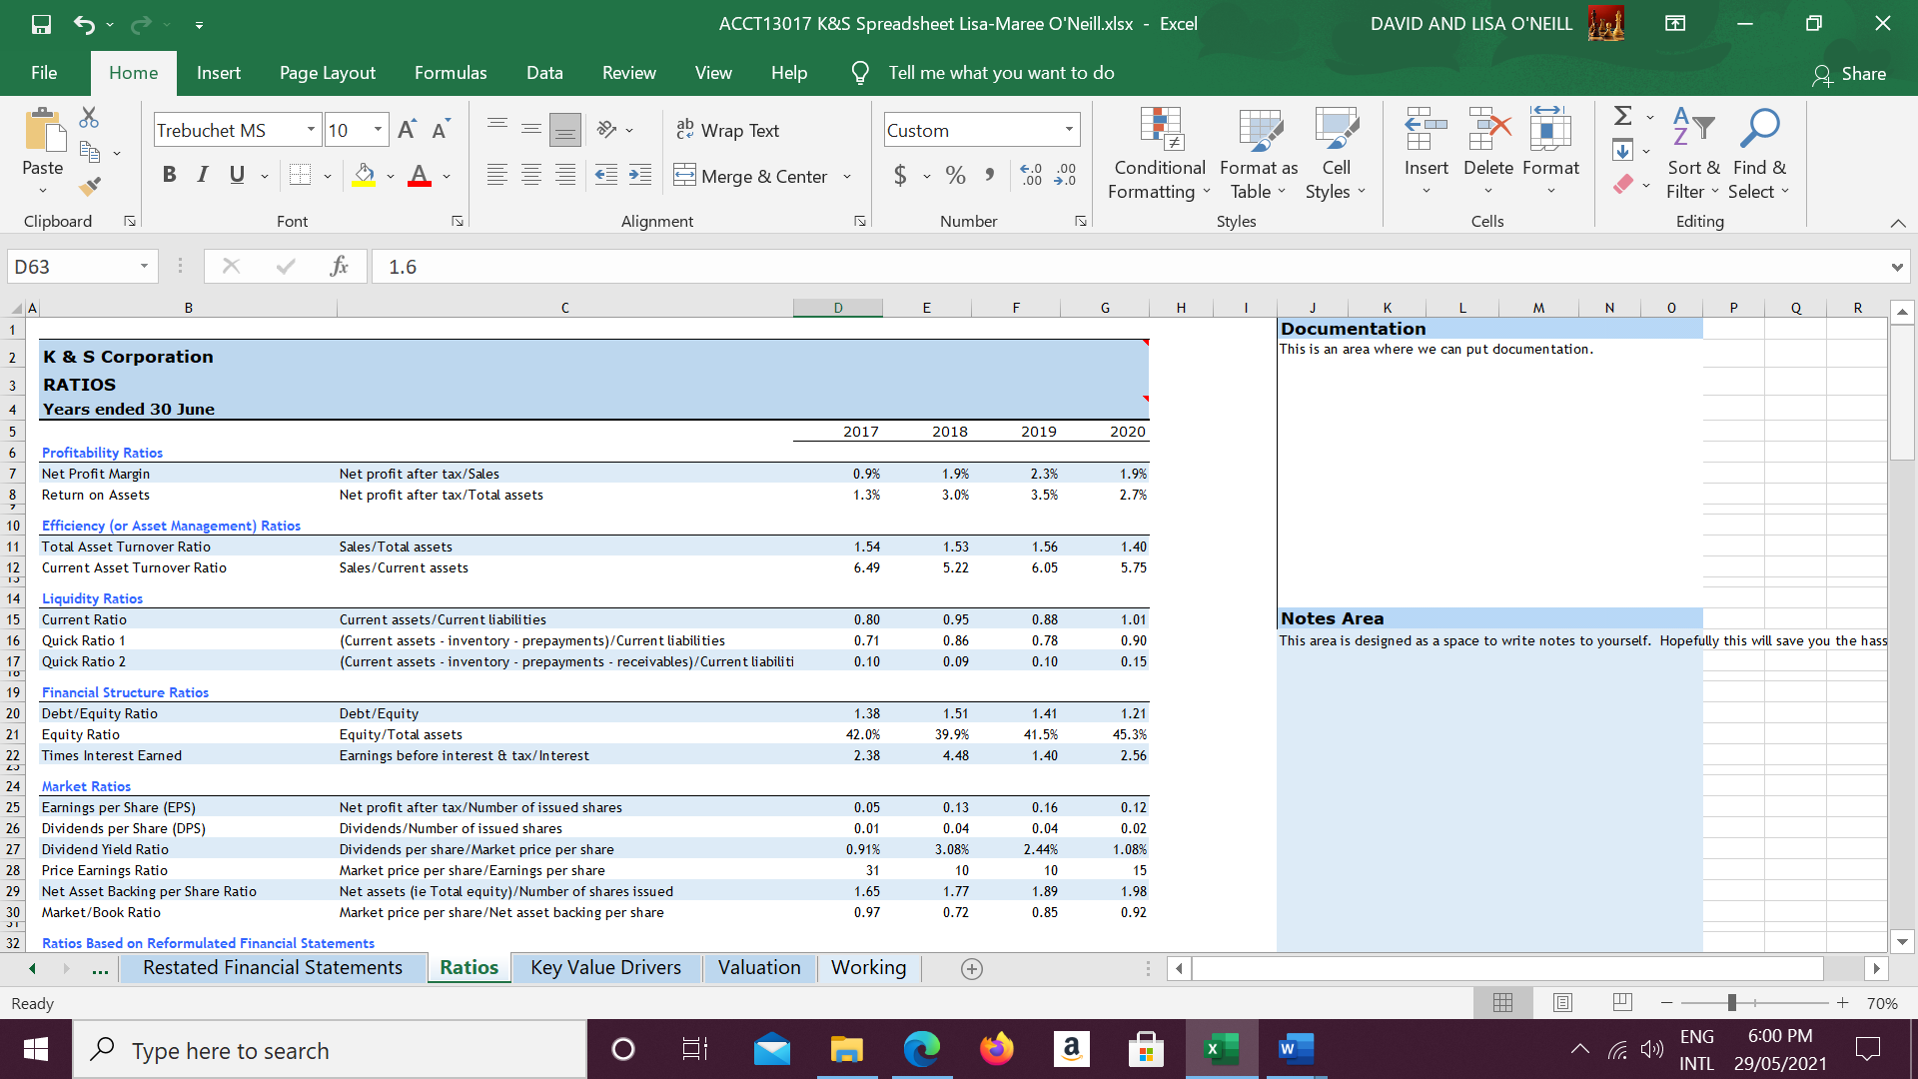
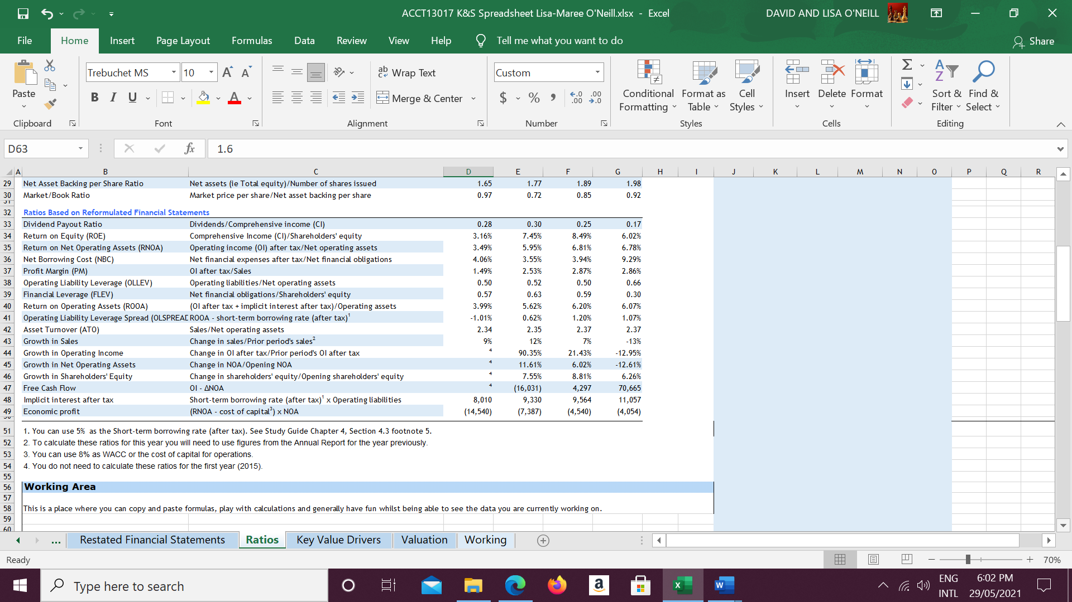

Blog posts and comments
https://imaccountingonyou.home.blog/2021/05/06/ratios-ratios-ratios/
https://imaccountingonyouhome.wordpress.com/2021/05/06/ratios-ratios-ratios/#comments
Ratios and Economic Drivers – Accounting with Talitha (wordpress.com)

STEP 4
ECONOMIC AND BUSINESS DRIVERS
Transport and logistics are the backbone of our country. Given the effects of the pandemic and even though K&S has seen a decrease in profits in 2020 and likely will see an additional decrease in 2021, I do think they will see growth in the future. At first my head was full of all these possible economic and business drivers and their connection to K&S’s accounting drivers. I thought it was going to be easy, then hard, now I have settled somewhere in the middle. I thought about what was driving their sales and net operating assets and what could positively and negatively impact this. Profit Margins and Asset Turnover increase and decrease with growth/declines in sales so the ability of K&S to achieve growth has been because of sales growth and movements in Net operating assets. Given they are an asset intensive company (their revenues are primarily generated from the large value of P, P & E that they have) the return on net operating assets is going to be influenced by an increase in net operating assets which in turn can increases sales which theoretically will increase operating income if operating costs are under control. If I had to pick one key accounting driver for my firm it would be net operating assets. Really looking at their financial statements and connecting what shows me to the ratios and then using my understanding of the ratios to connect to the accounting drivers and then connecting that to the economic and business drivers has been a huge learning curve for me, but I think the process of breaking everything down and focusing on operating activities has made the process a little easier to do. The following are what I believe to be K&S’s economic and business drivers.

Business Development and restructuring
The merger of Scott’s Transport Industries (STI) in 2017 was a significant business driver in the increase of NOA, RNOA, PM and ATO. This merger happened by the transfer of certain assets into K&S Freighters, a subsidiary of K&S Corporation. Under the agreement STI transferred its rights and entitlements under its customer contracts to K&S Freighters. K&S Freighters made offers of employment to transferring staff, recognising prior periods of service and value of accrued leave entitlements. Because the transaction involved common entities under control, it was elected to value the assets and liabilities of STI at book value at a merger date in K&S’s account. This resulted in no rise to any goodwill on consolidation and no gain/loss on the transaction, however it resulted in the recognition of a common control reserve within equity of K&S’s consolidated financial statements.
STI operations consisted of general freight and fuel cartage, in which they had several blue-chip companies within the manufacturing, fast moving consumer good and fuel sectors. The merger has allowed for K&S to expand its energy division through increased fuel cartage operations. It has also provided additional volume and competitiveness within its existing intermodal and contracts logistics divisions. From the date of merger to the annual report date in 2017, STI had contributed $45,783,399 of revenue and $1,248,710 to the profit before tax from contributing operations. The results in 2018 and 2019 showed the increases in operating income, increases to P, P&E and trade and other receivables which lead to increases in NOA. A roll-on effect was seen with the increase in profit margins and slight increase in Asset turnover, producing increases in RNOA. I believe this merger shielded K&S somewhat of the affects of the pandemic. Had it not have happened; they may not have been in as strong of a position to weather the negative effects that Covid-19 produced.
K&S’s focus in the last couple of years and moving forward is cost reduction strategies which have been achieved by business restructuring. By selling of underperforming operating segments and the cessations of contracts that weren’t producing positive outcomes, K&S has been able to decrease its liabilities somewhat. The replacement of specified fleet vehicles has also led to reductions in maintence costs associated with those fleets. Overall, the this has led to increases in operational efficiencies, which have been responsible for increases seen in operation income.

Diversification across contracts and industries.
K&S are extremely diversified across industry sectors, this diversification allows for increased sales revenue to be generated and when lower demand is experienced across certain industries, increases in other industries has allowed for sales to continue to grow. This diversification has driven the increases in sales revenues over the 2017-2019 period. Imports/exports have slowed as a result of covid 19. There have been a lot of challenges with getting certain materials into the country and this has the potential to affect contracts, which could decrease sales revenue and net operating assets further as has been seen in 2020. However, K&S have many contracts that remain strong and engage with many industries that are not experiencing overly negative effects from the pandemic. Moving forward I believe this diversification will continue to help K&S to grow in the coming years. It has also kept and will continue to revenues from declining too steeply as a result of covid-19. It is important for K&S to remain diversified as the transport and logistics industry is highly competitive and puts pressure on prices. The operating activities which contribute to driving the accounting drivers are outlined below:
Intermodal operations
K&S generate the majority of their sales revenue through transport services rendered which includes intermodal operations through road and rail.
Intermodal steel and timber volume from K&S’s major customers were still strong through the pandemic. Major infrastructure projects undertaken by various levels of government underpinned these activities and are projected to remain the same in the immediate future, despite the decrease in domestic builds. My husband works in construction and he has seen firsthand the shortages in materials that are needed for new domestic builds. This is a concern to me as declines in any volumes of materials K&S transport will affect their sales revenue and all accounting drivers.
Contracts and specialist logistics
K&S have a diversified customer base through their contract logistics business in which new contracts have been awarded each year and year on year growth has continued to be maintained. This has driven sales in an upwards direction and increased profit margins with it.
Heavy Haulage demand has been firm over the last 4 years and a significant number of contracts were renewed in the 2020 FY.
This is an area I see continuing to experience firm demand in moving forward. The more contracts they can secure and maintain will have positive outcomes on sales revenue. Provided operational costs are able to be kept under control, this will increase operating income and net operating assets though increases in trade and other receivables.
Chemical and fuel transport
The chemical and fuel transport business has seen improvement through growth and restructuring, but that has been offset by a fall in volume in 2020, especially given the decreased demand in fuel, directly attributed to the pandemic. What will the future bring for this side of operations for K&S? Further falls in volume could have a negative effect on sales revenue, but an increase can lead to the opposite.

Aviation services
Aero Refuelers was purchased by K&S in 2015. They provide aviation refuelling services and aviation fuel supply to regional airports and bulk purchasers such as flight schools and aerial agriculture operators across regional NSW and Victoria. The affects of the pandemic have produced negative results across this sector, which has attributed to the reduction in sales revenue and in turn operating income. Given the scale of the operations in terms of revenue generation, it’s not a huge area of concern to me. In saying that, fleet upgrades, expansion and refuelling installations have continued and I believe increases in domestic travel over the next few years, revenue will increase within this business segment.
Fuel Agency
The fuel trading business is a highly competitive market and one in which K&S has been able to produce sounds results in. Demand did soften in 2020, but the South Australian regional network marginally increased with the addition of a new service station and retail shop. Moving forward, increase assets in this area has the potential for increases in sales revenue.
New Zealand
Operations in New Zealand have and continue to produce solid results. Industries such as diary, timber and steel performed strongly in the 2020 FY despite stage 4 lockdowns. K&S are focusing on further growth and diversification of the revenue base in this segment. Strong growth in this area over the coming years will see growth in sales revenues.

Demand for transport services in Australia and New Zealand.
Consistent demand for transport services in Australia and New Zealand (revenue is primarily from operations carried out in Australia) has meant growth in sales, growth in net operating assets, and increases to profit margins and asset turnover. The 2020 period did see declines in demand; however, I believe that the demand for transport services both in Australia and New Zealand will continue to be consistent into the future. An increase in operating income and net operating assets will drive up RNOA, which is what needs to increase to inch K&S closer to a positive economic profit in the future. The pandemic did provide a lot of challenges for the transport and logistics sector, but no matter what events unfold, transport and logistics are still going to continue to be utilised. Foreseeing how demand is going to change over the coming years will present me with a few challenges that I will have to navigate my way thorough, however I firmly believe that there will be significant growth for K&S in the future of the back of increased demand. However, they are not a monopoly in the market so it’s hard to judge exactly how much growth is going to be able to be achieved.
Ability to invest in Plant, Property & Equipment
Adding assets increases the asset side of NOA, if operating assets grow quicker than operating liabilities, this will increase NOA. More NOA had led to increased sales revenue and operating income for K&S over the 2018-2019, thus increasing RNOA. Increases in RNOA is what will generate a positive economic profit into the future if the RNOA exceeds the costs of capital. This will however decrease the free cash flow, which is to be expected when investing into growth of the company. The higher value of plant property and equipment they have the higher sales revenues can be pushed which in turn should increase the return on net operating assets. K&S’s acquisition of Scott transport industries increased the net operating assets they have, driving up sales, profit margins and the return on net operating assets in the coming years. In 2020 there was a significant free cash flow value, which one would think will be used to buy assets in order to grow the business. K&S have indicated that this is what will happen. Fleets have been upgraded and additional assets are planning to be added this year. I expect NOA to increase in the future through the increase in value of Plant, Property and Equipment.

Fuel and fleet maintence costs
Given that K&S primary revenue generator is transport services the price of oil and fleet maintence costs will have a direct impact on the accounting drivers. Any increase in expenses has the potential to lower operating income.
K&S, from what I have learnt have a strong hold on their operating expenses. They are very vigilant in lowering costs and this coupled with increased operating revenues is what I believe has led to the increases in operating income that have been seen over the past couple of years. Yes, there was a decrease in 2020 as a result on the pandemic but the change was not significant enough to drive the operating income down enough to really affect the RNOA.
In saying this global trade tensions and other economic factors are really outside of their control something that I can only provide a somewhat educated guess on for the future. There are many areas to look at for consideration.

Safety/Compliance/Environment focus
Given the industry their certain risk factors and areas that need to be taken into consideration. K&S’s strong focus in the areas of safety, compliance and the environment help to ensure they are less exposed to hazards, which could result increases in liabilities and decreases in sales revenues, which would directly affect operating income.
The pandemic did present challenges however these challenges were met with strict controls which enables the group to continue operating effectively through the pandemic and as a result, no covid cases have been reported within the group, meaning no major implications that could have led to loss of revenues though employee and workplace isolations and temporary closures of warehouses.
K&S has and continues to invest heavily and proactively in load restrain training. Manual handling injuries have continued to decline in addition to decreases in Lost Time Injury Frequency Rates. This is an area that K&S make a very high priority and a key focus.
Emissions targets continue to improve with a 76% reduction from 2003 NOx levels seen realised in the 2020FY. The continuing positive trends here will ensure that legislative requirements are met which is important as any infringements could result in a heavy financial burden for the group operating activities.
Compliance standards have continually been met by the group. They maintain their ISO 9001:2015 accreditation standards as well as other standards such as their accreditation for HACCP/Food safety and TruckSafe accreditations.
What will be something to consider in the future is how legislative and compliance standards will change in result to environmental factors. I do think that K&S has the financial stability to be able to meet the challenges that can arise here. As long as fleet upgrades can continue to be done, I think K&S will more than meet what I required of them to continue their operations into the future.
Effects of Covid-19
I have mentioned Covid-19 in a couple of my economic and business drivers, but there are elements that need to be expanded on. Given the uncertainty of the virus, it’s hard to know what is going to happen in the future. Further increases in cases has the potential to impose increased safety measures which can affect the return on net operating assets. If further restrictions were put in place for warehousing staff and drivers, this has the potential to lower productivity. Lower demand due to temporary business closures can reduce sales revenues and difficulties with import/export and trade tensions have the potential to really drive revenue down. This in turn can decrease profit margins and asset turnover and operating income.
I’m confident with the diversification that K&S has across its contracts and industries that these possible effects will be minimised. When domestic and international travel is somewhat back to normal this will drive up revenue for K&S through their aviation services. When this is be is still very much so up in the air. A return to previous levels of sales revenue is something that I think will be achieved in the coming years which demand settling back to pre-covid levels.

Have I been able to connect my firm’s business and economic drivers to their accounting drivers? I believe I have been able too, but I’m not sure if it’s not specific enough. Many of what I deem to be business and economic drives tie in with one another, like the operations themselves and the diversification across contracts and industries, but I didn’t want to combine them all as one driver because I believe they drive the accounting drivers individually, if that makes sense? Is Covid and its effects an economic driver? I think so because it’s something that isn’t going away and has the potential to negatively affect my firms accounting drivers.
At this stage I am feeling quietly confident that I am going to be able to convincingly forecast my firms’ value into the future. What the DCF and Economic framework models show me took me a while to get my head around. Once it actually clicked, it opened up a whole new way of understanding what is happening within my firm and made me realise the importance of what they are telling me in order to be able to transfer that over to my forecasts and valuation.

STEP 5

